

“Malignant-Comments-Classifier Project”

Submitted by:

**RAHUL AHUJA**

**INTRODUCTION**

* Business Problem

The proliferation of social media enables people to express their opinions widely online. However, at the same time, this has resulted in the emergence of conflict and hate, making online environments uninviting for users. Although researchers have found that hate is a problem across multiple platforms, there is a lack of models for online hate detection.

Online hate, described as abusive language, aggression, cyber bullying, hatefulness and many others has been identified as a major threat on online social media platforms. Social media platforms are the most prominent grounds for such malignant behavior.

There has been a remarkable increase in the cases of cyber bullying and trolls on various social media platforms. Many celebrities and influences are facing backlashes from people and have to come across hateful and offensive comments. This can take a toll on anyone and affect them mentally leading to depression, mental illness, self-hatred and suicidal thoughts.

Internet comments are bastions of hatred and vitriol. While online anonymity has provided a new outlet for aggression and hate speech, machine learning can be used to fight it. The problem we sought to solve was the tagging of internet comments that are aggressive towards other users. This means that abuses to third parties such as celebrities will be tagged as inoffensive, but “u are an idiot” is clearly offensive.

Our goal is to build a prototype of online hate and abuse comment classifier which can used to classify hate and offensive comments so that it can be controlled and restricted from spreading hatred and cyber bullying.

* Motivation for the Problem Undertaken

Our motivation behind accepting this challenge is to build a prototype of online hate and abuse comment classifier which can used to classify hate and offensive comments so that it can be controlled and restricted from spreading hatred and cyberbullying. To achieve this we need to do the following.

* + Explore the dataset to get a better picture of how the labels are distributed, how they correlate with each other, and what defines malignant or clean comments.
  + Create a baseline score with a simple logistic regression classifier.
  + Explore the effectiveness of multiple machine learning approaches and select the best for this problem.
  + Select the best model and tune the parameters to maximize performance.
  + Build a final model with the best performing algorithm and parameters and test it on a holdout subset of the data.

**Analytical Problem Framing**

* Mathematical/ Analytical Modeling of the Problem

Platforms that aggregate user content are the foundation of knowledge sharing on the Internet blogs, forums, discussion boards, and, of course, social media.

But the catch is that not all people on the Internet are interested in participating nicely, and some see it as an avenue to vent their rage, insecurity, and prejudices.

Social media runs on user generated content, and is dependent on user discussion to curate and approve content. The problem with this is that people will frequently write things they shouldn’t, and to maintain a positive community this toxic content and the users posting it need to be removed quickly. But they don’t have the resources to hire full-time moderators to review every comment.

This problem is to develop a large open dataset of labeled social media Talk Page comments, which will be the dataset used for the project. The dataset is available through The dataset has six labels that represent subcategories of abusive language, but the project is going to focus on a seventh label that represents the general abusive language of the comments.Unfortunately for the problem, but fortunately for the social media, abusive comments are rare. Just over 10% of this dataset is labeled as abusive, but some of the subcategories are extremely rare making up less than 1%of the data.

* Data Sources and their formats

The data set contains the training set, which has approximately 1,59,000 samples and the test set which contains nearly 1,53,000 samples. All the data samples contain 8 fields which includes ‘Id’, ‘Comments’, ‘Malignant’, ‘Highly malignant’, ‘Rude’, ‘Threat’, ‘Abuse’ and ‘Loathe’ The label can be either 0 or 1, where 0 denotes a NO while 1 denotes a YES. There are various comments which have multiple labels. The first attribute is a unique ID associated with each comment.

The data set includes:

* + - Malignant: It is the Label column, which includes values 0 and 1, denoting if the comment is malignant or not.
    - Highly Malignant: It denotes comments that are highly malignant and hurtful.
    - Rude: It denotes comments that are very rude and offensive.
    - Threat: It contains indication of the comments that are giving any threat to someone.
    - Abuse: It is for comments that are abusive in nature.
    - Loathe: It describes the comments which are hateful and loathing in nature.
    - ID: It includes unique Ids associated with each comment text given.

* + - Comment text: This column contains the comments extracted from various social media platforms.





* Data Pre-processing Done

Below are the steps taking for pre-processing and cleaning the data for the  
 analysis.

* The data set contains the training set, which has approximately 1,59,000 samples and the test set which contains nearly 1,53,000 samples.
* All the data samples contain 8 fields which includes ‘Id’, ‘Comments’, ‘Malignant’, ‘Highly malignant’, ‘Rude’, ‘Threat’, ‘Abuse’ and ‘Loathe’
* The data types (Columns name Id and the Comment text) are in object and rest columns (‘Malignant’, ‘Highly malignant’, ‘Rude’, ‘Threat’, ‘Abuse’ and ‘Loathe’) are in integer type.
* The label can be either 0 or 1, where 0 denotes a NO while 1 denotes a YES.
* There are no null values.
* 16225 out of 159571 comments, or 10.17%, are classified as some category of malignant.
* 1595 highly_malignant comments. (1.00% of all data.)

• 1595 or 100.00% were also malignant.

• 1517 or 95.11% were also rude.

• 112 or 7.02% were also threat.

• 1371 or 85.96% were also abuse.

• 313 or 19.62% were also loathe.

* 1405 loathe comments. (0.88% of all data.)

• 1302 or 92.67% were also malignant.

• 313 or 22.28% were also highly_malignant.

• 1032 or 73.45% were also rude.

• 98 or 6.98% were also threat.

• 1160 or 82.56% were also abuse.

* 15294 malignant comments. (9.58% of all data.)

• 1595 or 10.43% were also highly_malignant.

• 7926 or 51.82% were also rude.

• 449 or 2.94% were also threat.

• 7344 or 48.02% were also abuse.

• 1302 or 8.51% were also loathe.

* 7877 abuse comments. (4.94% of all data.)

• 7344 or 93.23% were also malignant.

• 1371 or 17.41% were also highly_malignant.

• 6155 or 78.14% were also rude.

• 307 or 3.90% were also threat.

• 1160 or 14.73% were also loathe.

* 478 threat comments. (0.30% of all data.)

• 449 or 93.93% were also malignant.

• 112 or 23.43% were also highly_malignant.

• 301 or 62.97% were also rude.

• 307 or 64.23% were also abuse.

• 98 or 20.50% were also loathe.

* 8449 rude comments. (5.29% of all data.)

• 7926 or 93.81% were also malignant.

• 1517 or 17.95% were also highly_malignant.

• 301 or 3.56% were also threat.

• 6155 or 72.85% were also abuse.

• 1032 or 12.21% were also loathe.

* The skewness is available in the data but since the data are in Label format it will not the area of concern
* Rectified and cleaning the string data and replace all the unnecessary details with the relevant ones using NLP.
* Use WordCloud method to create word cloud layout.
* Data Inputs- Logic- Output Relationships

The data has been categorized into two and that has been given x and y

x is an input data for the model which contains the complete data which includes all columns ‘Id’, ‘Comments’, ‘Malignant’, ‘Highly malignant’, ‘Rude’, ‘Threat’, ‘Abuse’ and ‘Loathe’

y data contains the output of the model which will be given to the model for the learning. For this we have refined the data and created a new column with the “bad” which is the combination of the labels of the columns (Malignant’, ‘Highly malignant’, ‘Rude’, ‘Threat’, ‘Abuse’ and ‘Loathe

**Model/s Development and Evaluation**

* Identification of possible problem-solving approaches (methods)

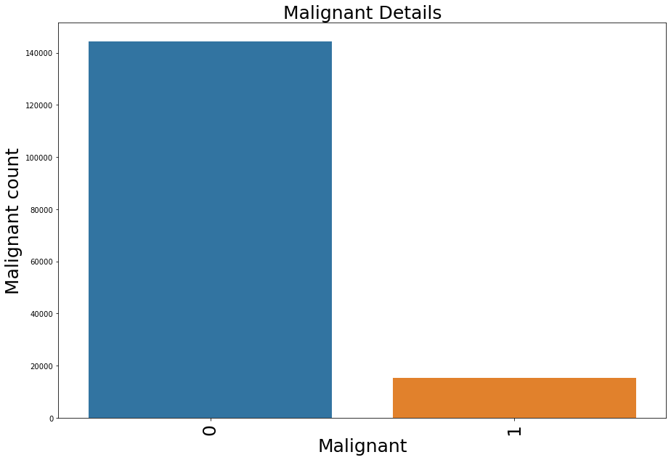 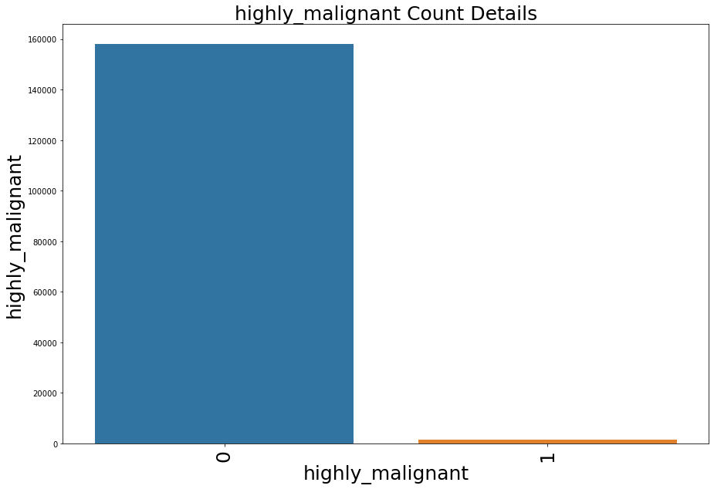

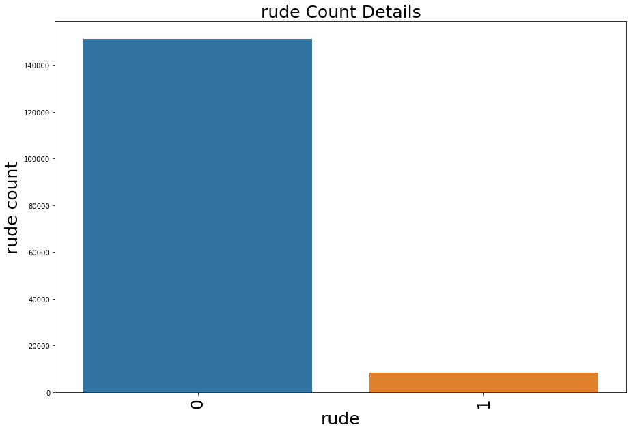 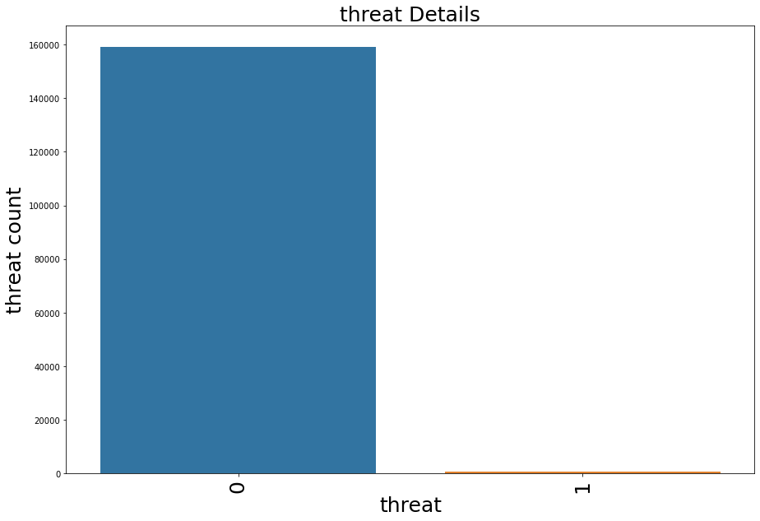

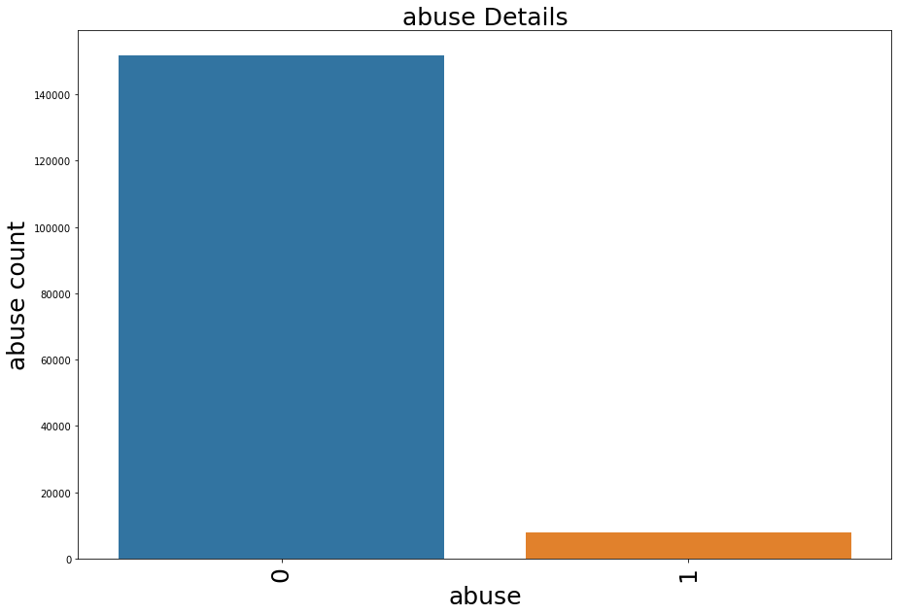 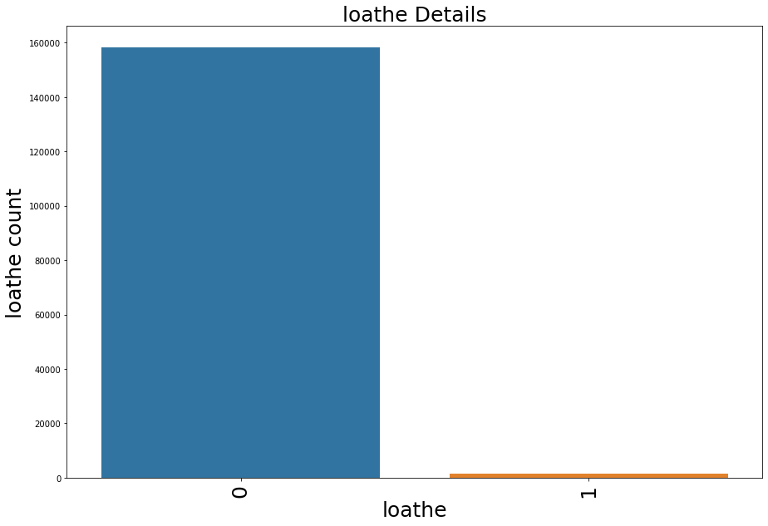

HISTOGRAM

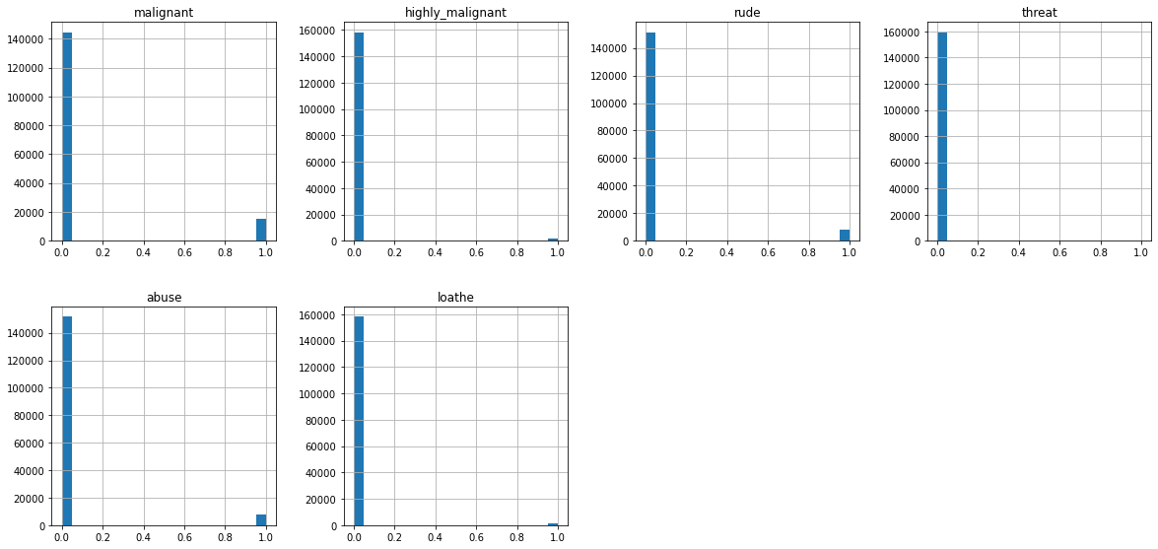

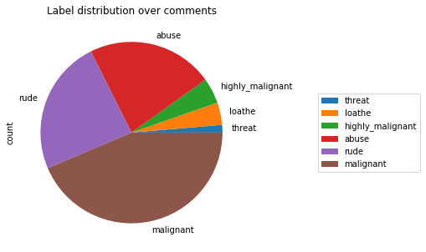

**WORD CLOUDS**

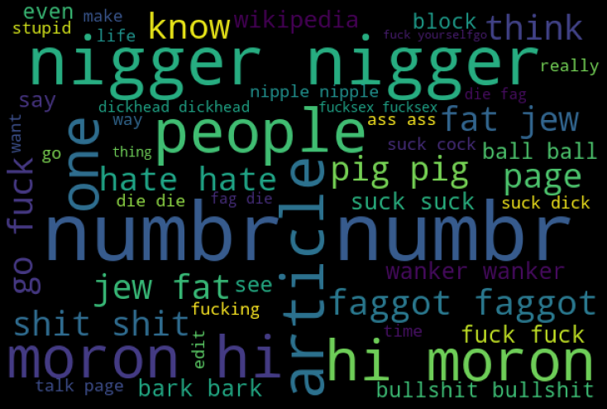 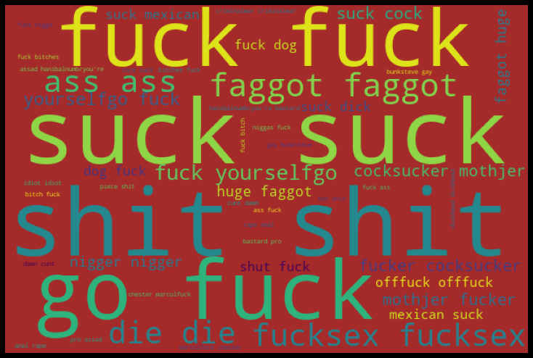

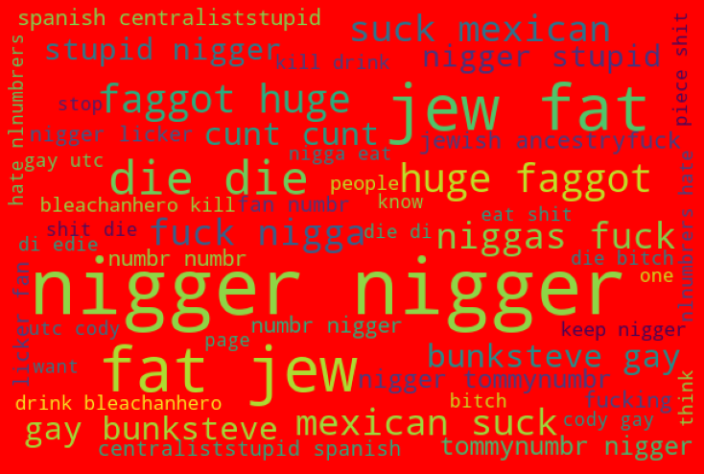

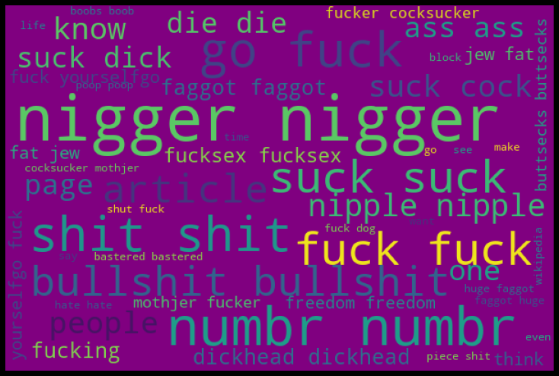 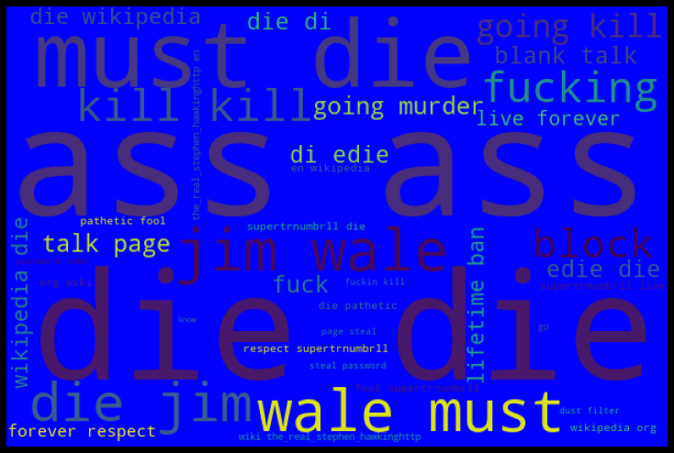

**CORRELATION CHART**

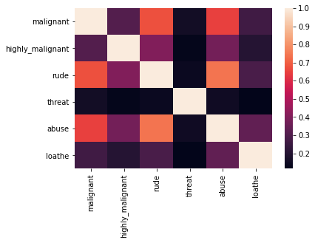

**Bad Words Counts Data**

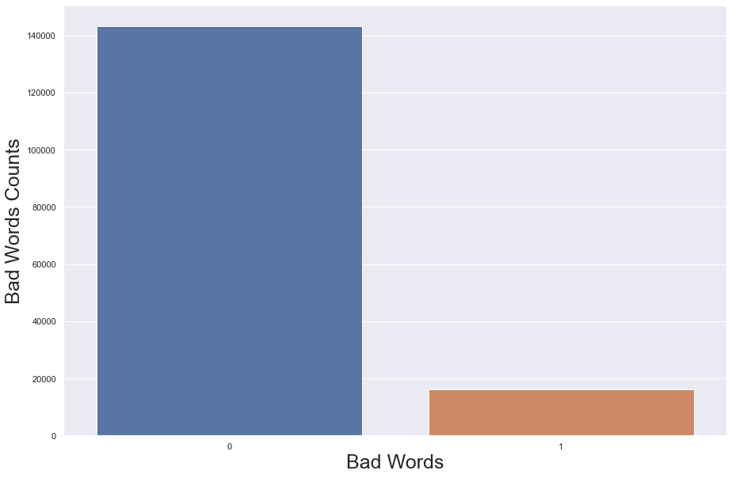

**Skewness in Data**

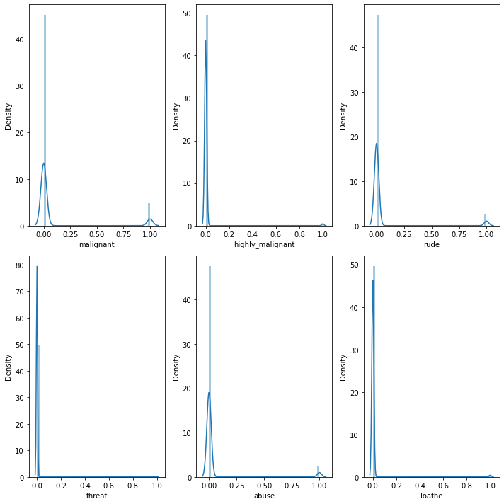

* Conclusions of the Study

Below is the conclusion.

After refining the data we have tested different classification models like Logistics   
 Regression, Decision Tree Classifier, K Neighbors Classifier, Random Forest   
 Classifier, Ada Boost Classifier and the. After checking all this   
 we have found that the Random Forest Classifier has provided the best result.   
 The score of the same is mention below.



AUC-ROC CURVE

